**Title: AI-Driven Vehicle-to-Vehicle Communication System**

**Introduction :**

With increasing traffic congestion and road safety concerns, vehicles need smarter ways to navigate efficiently. Our **Vehicle-to-Vehicle (V2V) Communication System** enables cars to share real-time information, such as traffic updates, road conditions, and weather, to improve driving experiences. This AI-driven system uses data from multiple vehicles to recommend optimal routes and enhance road safety.

**Objectives :**

1. **Efficient Route Optimization**:
   * Identify the fastest routes based on live data.
2. **Improved Safety**:
   * Provide real-time alerts for poor road conditions or weather.
3. **Traffic Management**:
   * Help reduce congestion by distributing traffic evenly.
4. **Data-Driven Insights**:
   * Enable users to make informed travel decisions.

**How It Works :**

1. **Data Collection**:
   * Vehicles communicate with one another through sensors and share key information (e.g., speed, road conditions, and weather).
2. **Processing and Analysis**:
   * A central server collects this data and processes it using AI algorithms to predict optimal routes and travel times.
3. **Route Recommendations**:
   * Vehicles receive real-time updates, showing the best routes, estimated times, and alerts.
4. **Continuous Updates**:
   * The system continuously updates recommendations based on changing conditions.

Example:  
A car traveling from **Salem to Coimbatore** gathers live data from nearby vehicles. It analyzes traffic patterns and weather conditions to recommend the smoothest and safest route.

**Features :**

* **Real-Time Data Sharing**: Vehicles exchange information instantly to ensure accuracy.
* **Dynamic Route Optimization**: AI suggests the fastest routes, reducing travel time.
* **Weather and Road Alerts**: Warn drivers about hazards like rain or potholes.
* **Continuous Monitoring**: Keeps updating based on traffic and conditions.

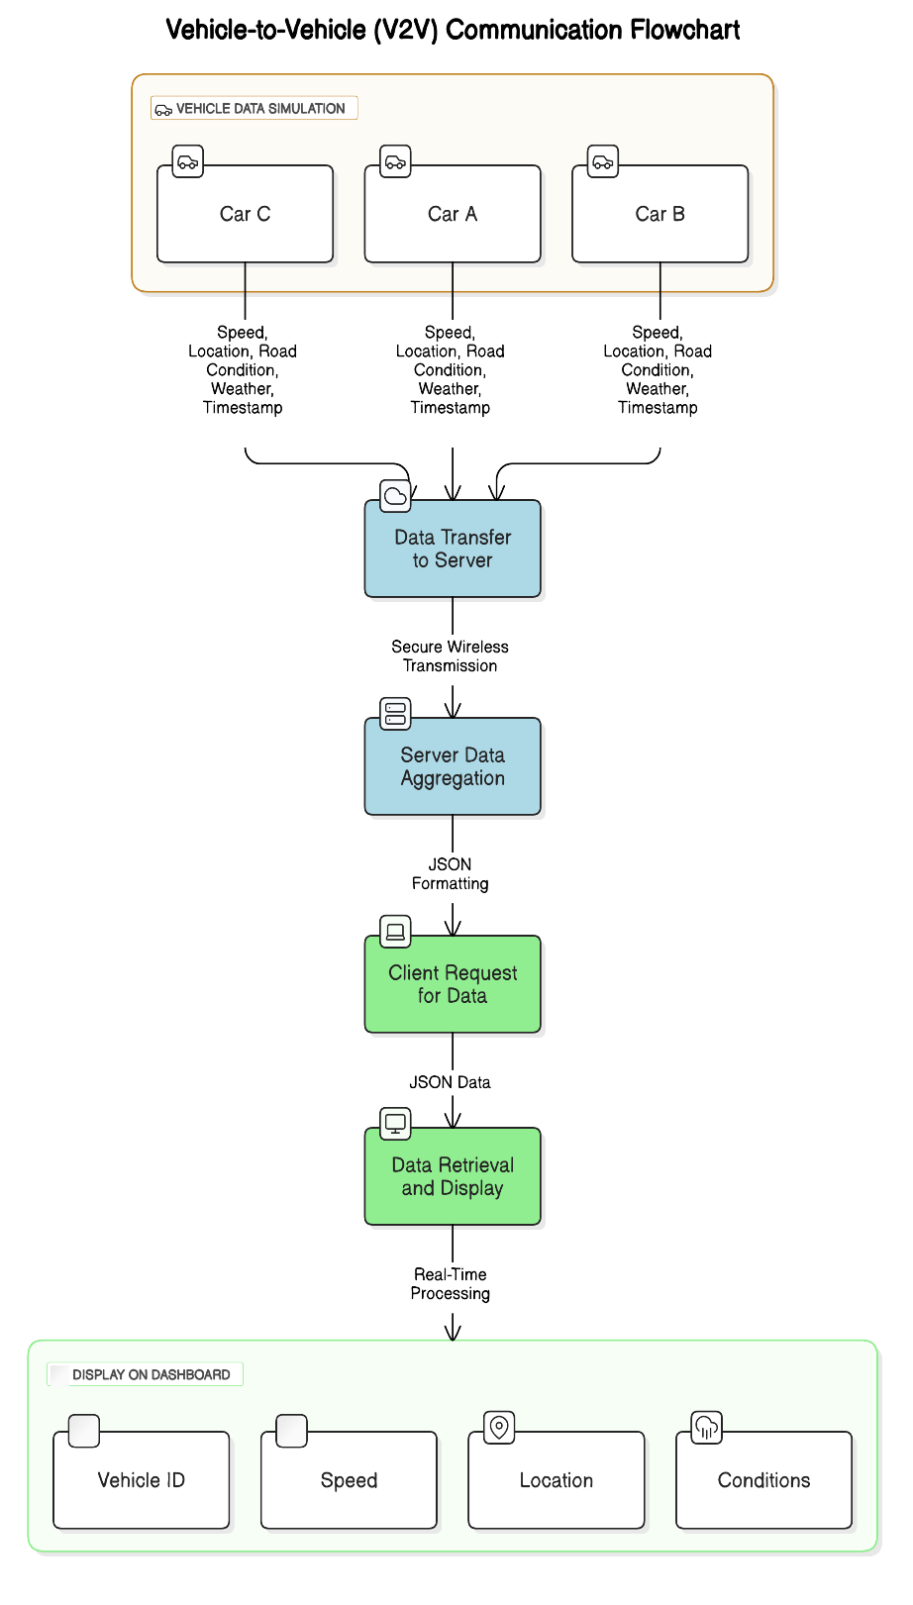**Architecture Diagram:**

**Technologies Used :**

* **Backend**: Flask, Python.
* **Frontend**: HTML, CSS, JavaScript (for dashboard visualization).
* **Database**: SQLite to store vehicle data.
* **Communication Protocols**: Socket.IO or MQTT for real-time communication.
* **AI/ML**: Scikit-learn for predictive analytics.

**Applications :**

* **Smart Cities**: Integrate the system into city-wide traffic management.
* **Fleet Management**: Optimize routes for delivery or ride-sharing services.
* **Safety Systems**: Reduce accidents through proactive alerts.

**How It Works in Practice:**

* Let’s say **Car A** is traveling from Salem to Coimbatore and starts its journey at 9:00 AM.
* Along the way, **Car A** communicates with other vehicles (**Car B**, **Car C**, etc.) traveling on the same route.
* At 9:30 AM, **Car B** detects an accident near a specific point. It shares this information through the V2V network.
* At the same time, **Car C** is traveling through a section with heavy rain, and its sensors detect slippery roads, sharing this information with the network.
* **Car A** then receives updated route suggestions, warnings about road conditions, and ETA adjustments based on the data collected from **Car B** and **Car C**.
* The AI processes all this information and suggests a safer, faster route for **Car A** to avoid the accident and slow traffic ahead.

**Conclusion**

This **Vehicle-to-Vehicle Communication System** revolutionizes driving by creating a collaborative and efficient ecosystem. By leveraging AI and real-time data, it not only saves time and fuel but also enhances safety for all road users